**CP3407 ASSESSMENT TASK 1: Project Plan**

**Lecturer: Da Sheng Liu**

**GITHUB link:** [**https://github.com/kkw123/CP3407_Assignment**](https://github.com/kkw123/CP3407_Assignment)

**This assignment is done by two students.**

**Group 2**

|  |  |  |
| --- | --- | --- |
| **Student name** | **Student ID** | **Project role** |
| Tan Jia Qi | 13671065 | Scrum Master, member, project developer |
| Kum King Wye | 13414829 | Scrum Master, member, project developer |

**---------------------------------------------for writing menu uses-------------------------------------------**

**Project description for non-ICT-technical stakeholders and general audience.**

1. **Justification for the project:**

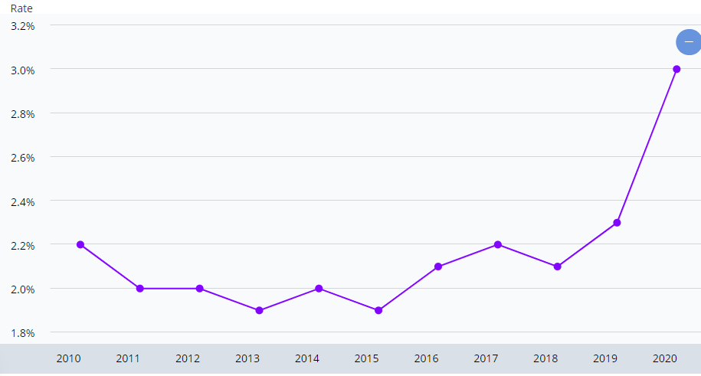

**( Annual average unemployment rate in Singapore)**

COVID-19 epidemic began from Wuhan, China and spread globally since early 2020 has caused serious impacts on finance and country growth. Huge changes among employment patterns reduce effectiveness during work and turn into unemployment along closing-down of companies and factories. According to Trading Economic News, the unemployment rate still increased from 2.8% to 3.6% in Singapore even though with the funds and support from the government. During the outbreak, bankrupts, shutdowns and closures have affected both employees and employers and result in the largest imbalance of supply and demand chain in the labor market. After we realized this problem and discussed it deeply about it, we have decided to provide a platform to create a better connection between employers and employees, which stands for people who seek jobs and people who are hiring for their own good, in order to reduce more side effects caused by unemployment in Singapore.

This platform is not only focusing on helping jobless people to find their desired jobs, it also helps people with specific skills and fresh graduated students to perform themselves. At the same time, this platform also will discover more fresh or small enterprises and act as their first move into public eyeballs. Gathering all resources online also becomes a solution to prevent the spreading of COVID-19 as everyone can stay at home or still improve themselves during the outbreak period. At the same time, this platform will improve employment rate by increasing the collaboration between the government, industry and universities. The industry demand for the hiring process still can be solved including full time, part time or internship.

According to research in, the fact that low income people are more affected by this epidemic compared to high salary positions. The lower the salary, the higher the percentage of year-on-year decline in the number of positions in the first quarter of 2020. (Rachel, 2020). At this moment, everyone has a hard time so extension of portals that provide job seeking services will increase the bonds among government, industry and peoples which will improve development of the economy and country for growth. If our platform and services provided can help people and fulfill their desires, this means it is worthy and will successfully contribute to this country.

1. **Project goals:**

There are a lot of job seeking platforms which were invented before us and achieve outstanding success such as LinkedIn. Thus, beside those benefits above I have mentioned, we need to figure some special features over them and attract users to believe that our website is useful and attractive.

First, we will filter those jobs without clear information or information that misleads our users. At the same time, this move will decrease privacy leakage and illegal activities. Improving the terms and conditions before users accept to enhance their experience. Although this will require a long period of effort to update our website frequently, it is worth it to prevent any criminals, hackers and any users with fake identity.

Next, the most important aspect of our website is the wish to connect companies and job seekers in a better and modern way. Thus, we will not only collect users’ information but also get to know them better than them to discover what they really want. We will try our best to direct them to find what they want in a flexible and efficient way. Processing information back to users is always needed to be accurate and specific so that the unemployment problem can be solved in a timely manner.

Furthermore, there will be news and other real time information to make users understand which company or occupation is on trending. Urgent recruitments in company or specific requirements may advertise to make sure they are stated on top for users to get information more directly on the first look. Our websites also will always keep up to the newest technology or new launched company to try our best to provide any job chance as we can.

According to research from the 2020 International Institute for Management Development, Singapore has voted as the most competitive economies on global. Therefore, we are providing our product which is not only limited to full-time jobs, while also providing internships and part-time jobs as well. Since this epidermis has brought difficult times for every part of the global corner, our platform will improve their job satisfaction by filtering and balancing different types of jobs which are suitable for different kinds of users.

Last but not least, keep in mind, we are creating a simple yet efficient job seeking platform. We will always make sure that it is easy to use and keep the design of the website neat and not complicated at all. Most importantly, it is always reliable having a perfect resume before employers decide whether to interview with job seekers, especially in this epidermis period. Therefore, our platform will provide resume filling recommendations to increase possibility of success employment

**Project Planning and scope**

**Basic project scope:**

|  |  |  |
| --- | --- | --- |
| **User stories** | **Description** | **Estimated days taken (55 days)** |
| 1. Start up process **-** Users wish to see a neat but comfortable homepage. | Users enter our website link to hire or seek for a job. Our platform will be attractive for people to browse. | **8 days** |
| 1. Users wish ro sign up to set up their profile. | Sign up page displayed on screen and led users to enter their email and password (recommend strong password) | **8 days** |
| * Employees wish to customise their profile or upload a resume in format. * Employers wish to customise their company profile and the roles they need to hire. | Allows them to edit their profile (name, age, residential place, nationality, contacts) and add skills, work experience, wishlist occupation, qualifications, certificate, when they can start work, job types and any description about themselves.  Allow them to provide company details, contacts and websites or social media links and add specific requirements, basic salary range, least requirement, job types and details, working hours. | **10 days** |
| 1. Users wish to enter keywords to find what they want. | Keyword search engines are not just limited to occupation, but also location, job types (part-time, internship, full-time, contract), company name or skills required. | **8 days** |
| 1. Users wish to know more about the company details or job seekers details. | Chat box will be at the corner if users do not want contact through emails or phone. It allows better communication and gets to know deeper about roles before interview. | **5 days** |
| 1. Users wish to give us feedback, complain or report to us any matter about our services or incident. | Our customer service will be online and handle cases like missing password, identity theft, report abuse or fake identity issues, or report any criminal issues. Any feedback will always be accepted by us to improve our platform. | **5 days** |
| 1. Users wish their personal information to be protected. | Our platform will always be secure and update frequently. Our terms and condition of our cookies will be stated clearly before they agree to sign up. | **2 days** |
| 1. Users wish they can be discovered by their desired companies or in urgent hiring. | Our platform will provide a stage if any user may advertise to get their jobs in a short time. | **4 days** |
| 1. Users wish to get notification when some jobs match their condition. | Our portal will ask permission whether they want to get notification linked to their user account as a reminder. | **5 days** |

**Total = 55 days**

**Other consideration on different roles:**

|  |  |
| --- | --- |
| **User stories (total 9)** | **Solutions** |
| **I am a college student and wish to look for a part time job :**  Nowadays, all my classes and lectures turn to online classes so I wish to look for a part time job to earn some extra money for my expenses and gain some experience as well. | Users without working experience at all can try out their first part time job as our portal provides short term job contracts with flexible time which is suitable for users who have free time. |
| **I am a clothes shop owner that my business affected by lockdown :**  I wish to change all my full time workers to part time and pay them hourly salaries that can work on weekends only. | Employers can fix their least requirements working retail hours and least relevant experience if they want. |
| **I am running a company and wish to hire people for some specific departments :**  I would like to hire people who are fluent and able to communicate with Japanese or Korean language as I am planning to expand my business so I need a translator. | Our portal will process these special requirements to job seekers as users' profiles will state their language ability as a skill as well. |
| **I just opened a cafe currently and wish to hire people :**  I like to hire experienced service crew and barista with a certificate only as I want my cafe to be really professional and do not need any training. | Our portal will state the requirements that employers need and process these information to job seekers to prevent any mislead before users filter them. |
| **I am a factory worker however my factory was forced to shut down:**  I wish to look for another similar factory to work since I only have relevant experience in this area. | Our portal allows users to type in their formal company name and look for other companies in that similar field. Users may add their skills and relevant experience in their profile. |
| **I am a mother who wish to look for a freelance job and only work at home :**  I had my accountancy diploma qualification so I wish a company would accept me from home since I need to take care of family. | Our portal will filter needs depending on their keywords such as “work from home” or “flexible timings” to direct them accurately. |
| **I am a 48 years old female and wish to look for a job online through the web :**  It is very hard for me to understand those job seeking platforms as I am not familiar with all these technologies. During COVID-19, this is harder to just straight walk in and interview like before. | Our portal will be designed as simple as well to help users that are not familiar with technology and add some guide features for new users for better navigation. |
| **I am a fresh graduate in the computer science field :**  It has been really difficult to enter the job market because COVID 19 has stretched many companies’ budget thin and they cannot afford to hire fresh graduates. | Our portal will add a resume completion process to help create a better resume for the first impression when users are applying. Besides, cooperating with some new launched companies will increase the chance to accept internships. |
| **I just got fired and only have secondary school qualification :**  I looked for other job seeking portals and those companies did not even state their requirements clearly so I thought they accepted my qualification. | Our portal helps users even with low qualification by cooperating with factories that need massive amounts of workers. Our jobs provided were not just limited to professional occupation only. |

**Project Design**

1. **Architectural model :**

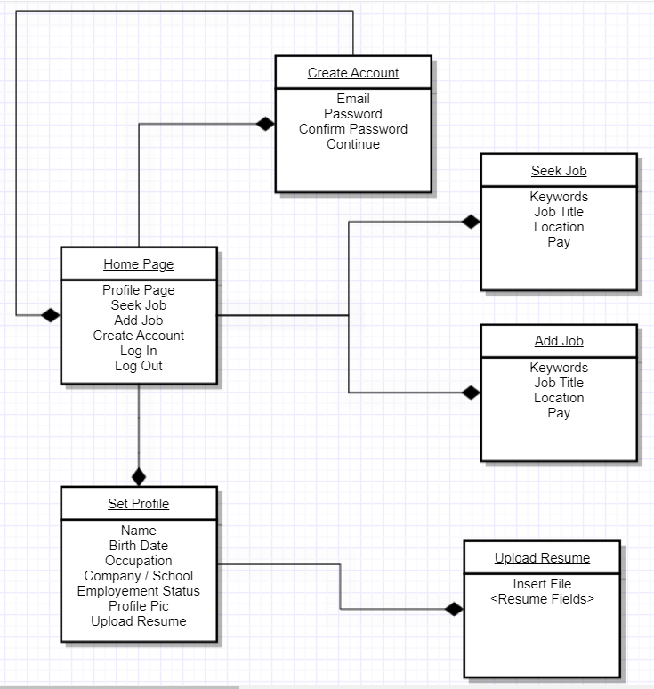

1. **Database designs:**

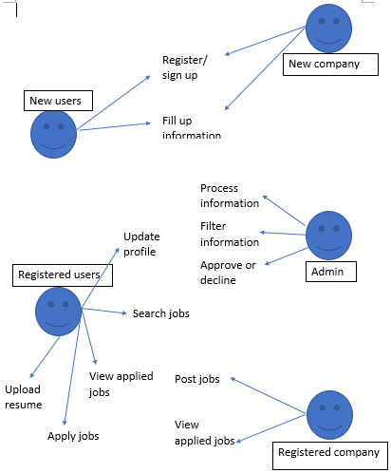

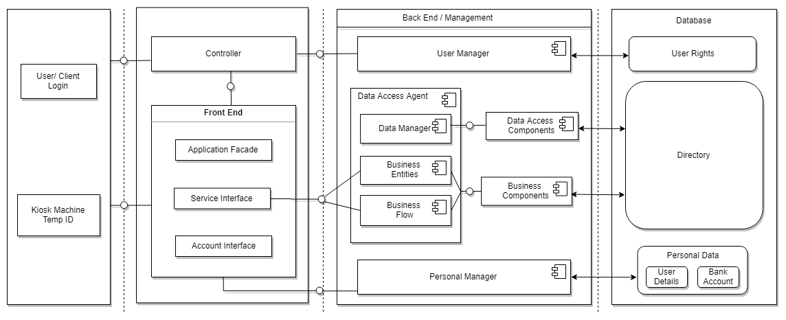

1. **Interface design:**

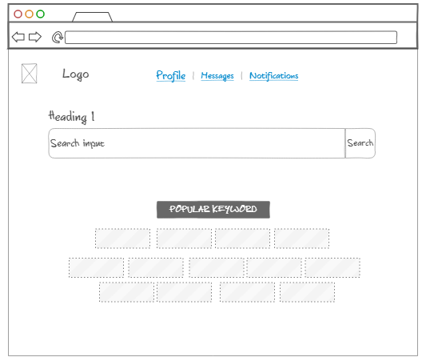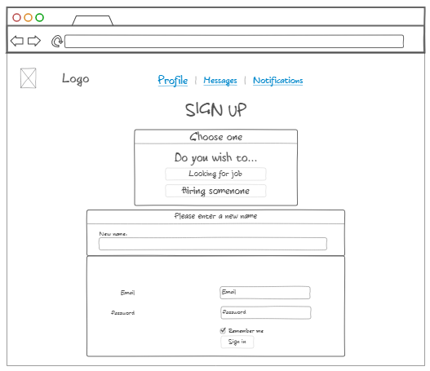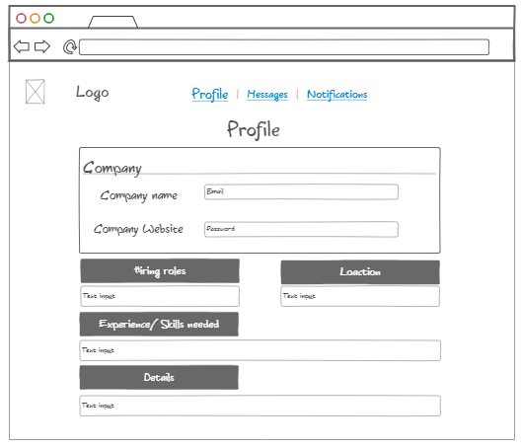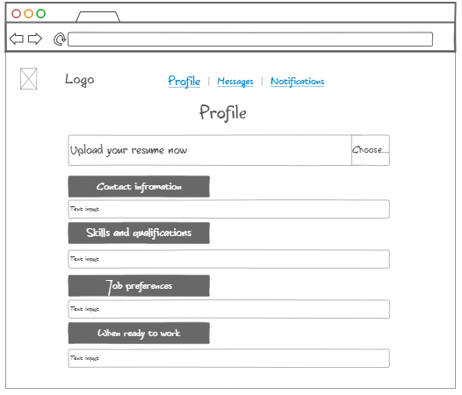

**Project development and release ICT infrastructure**

**Development environment**:

As this situation, our lecture and practical class reverted to online so we mostly work from home when discussing starter ideas and designing interfaces, we will conduct weekly stand ups and updating our improvement on Trello for a better planning process.

We used Figma as our basic prototype development as it is convenient, easy to navigate and able to invite to others.

**Project collaboration tools:**

Trello will be used as our implementation of project movement and any updates. Mostly we discussed it through whatsapp. My group members also create a group with the lecturer in Wechat for any enquiries. Besides, we also always update our situation and any difficulties we met through every practical class when the lecturer was keeping up with us group by group.

**Programming languages:**

* HTML
* CSS
* JavaScript

**Development tools:**

Our website will use the Wordpress CMS platform which provides an easy way to create a website as the server automatically creates pages based on the content in the database. We eventually decided to use a CMS due to its ease of usage, security and high quality eventual product. There are 2 main things that make Wordpress a valid choice for our project. These being the creation process of the website’s interface and overlay and the management of the website’s backend.

Wordpress makes it simple to create the website interface as it has a block editor that allows you to simply drag and drop widgets into a page and fit them to where you want them to be. Widgets can also be premade by downloaded plugins which brings me to my next point. Plugins also make it easier for us to customise our content for the website. They can be as simple as WP Forms which just allows us to create forms and send user answers to a database or something more complicated WP Travels which is a travel operator and travelling booking platform that automatically creates many pages and widgets based on the creator’s trips and destinations.

Wordpress also makes it easier to manage the backend of the website such as a database of user information. As stated before, Wordpress already has built in web security features and so we do not have to worry much about whether we can keep our database safe from hackers. There are many plugins that can help with the creation and management of user registrations such as WP User which even allows the creation of an OTP to make an account completely secure from attackers. Wordpress already has its own development tool inbuilt to the website being created. Wordpress also uses Git for version control which makes it easy to revert unintended or incorrect changes to the website.

**Github link:**

<https://github.com/kkw123/CP3407_Assignment>

**Trello link: (that we set it as public view)**

<https://trello.com/b/DRncubVL/cp3407-group-2>

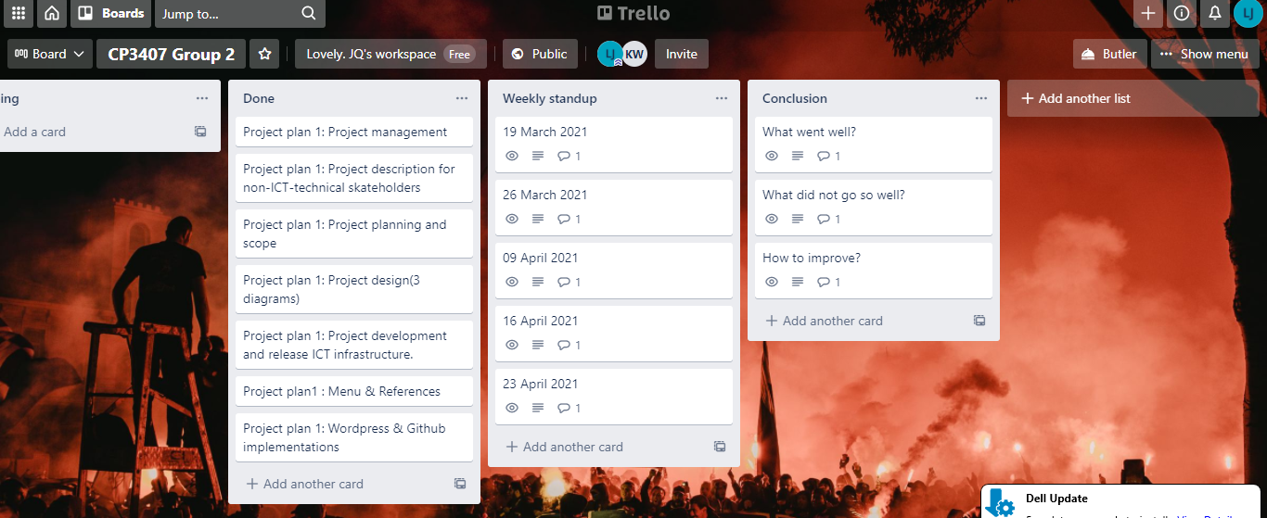

**Figma Prototype Link: (already set as public view)** <https://www.figma.com/file/5dCVej1qHOWTCs4aRyRr2x/CP3407-Project?node-id=0%3A1>

Here is some screenshots of prototypes below

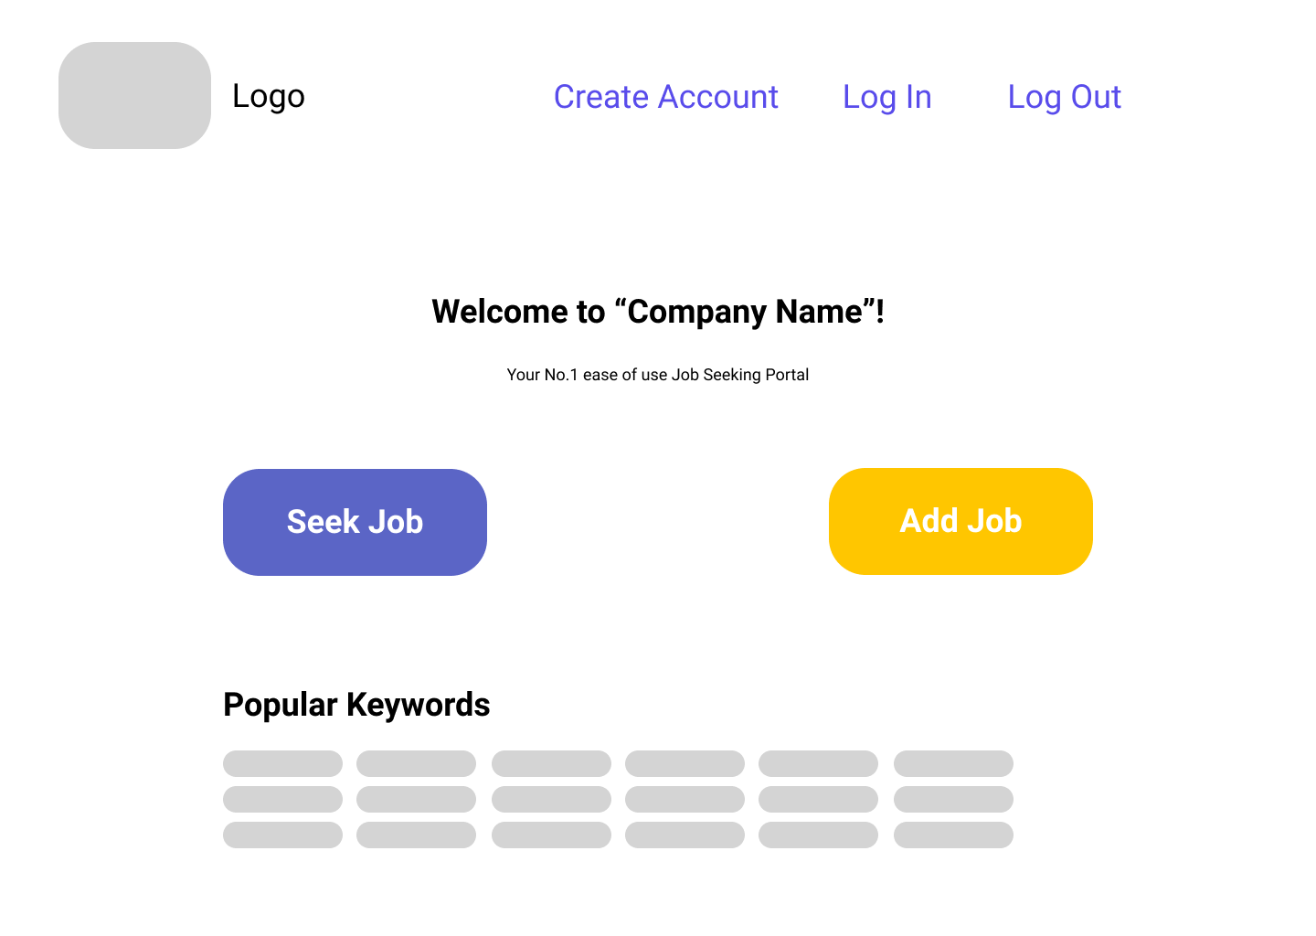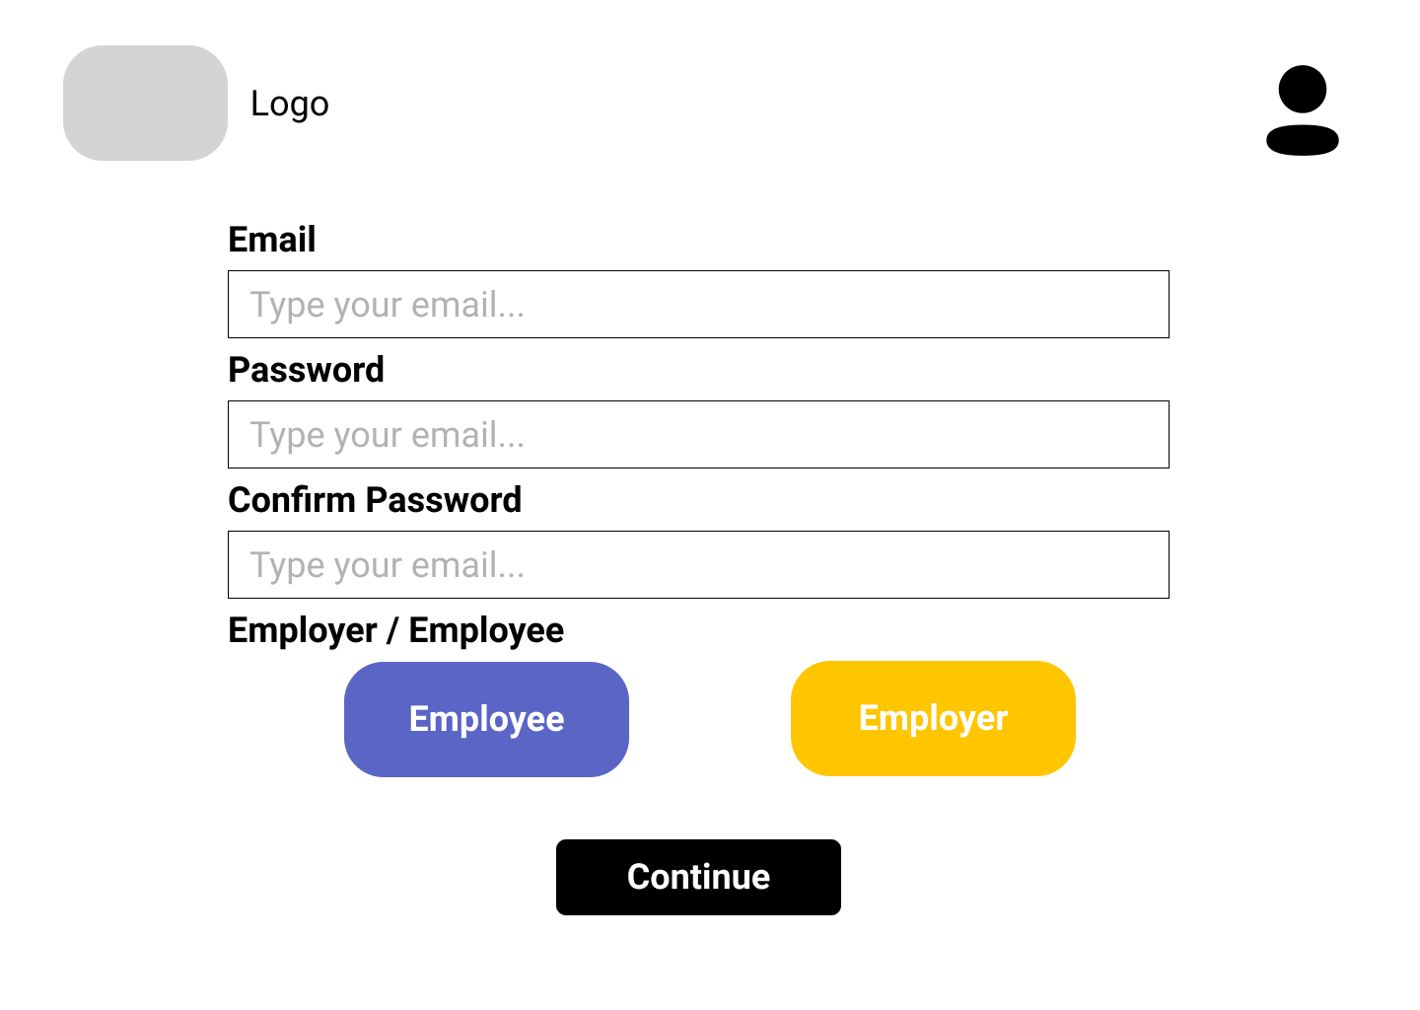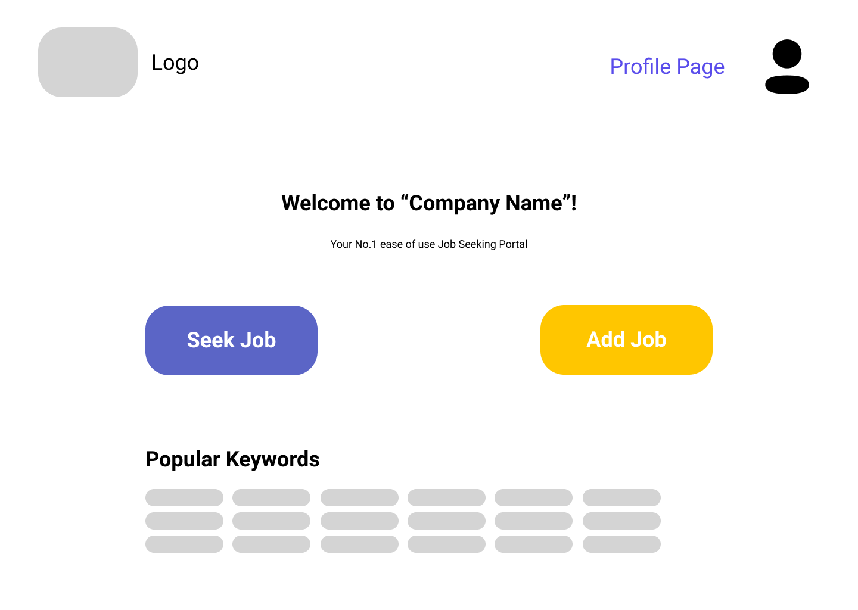

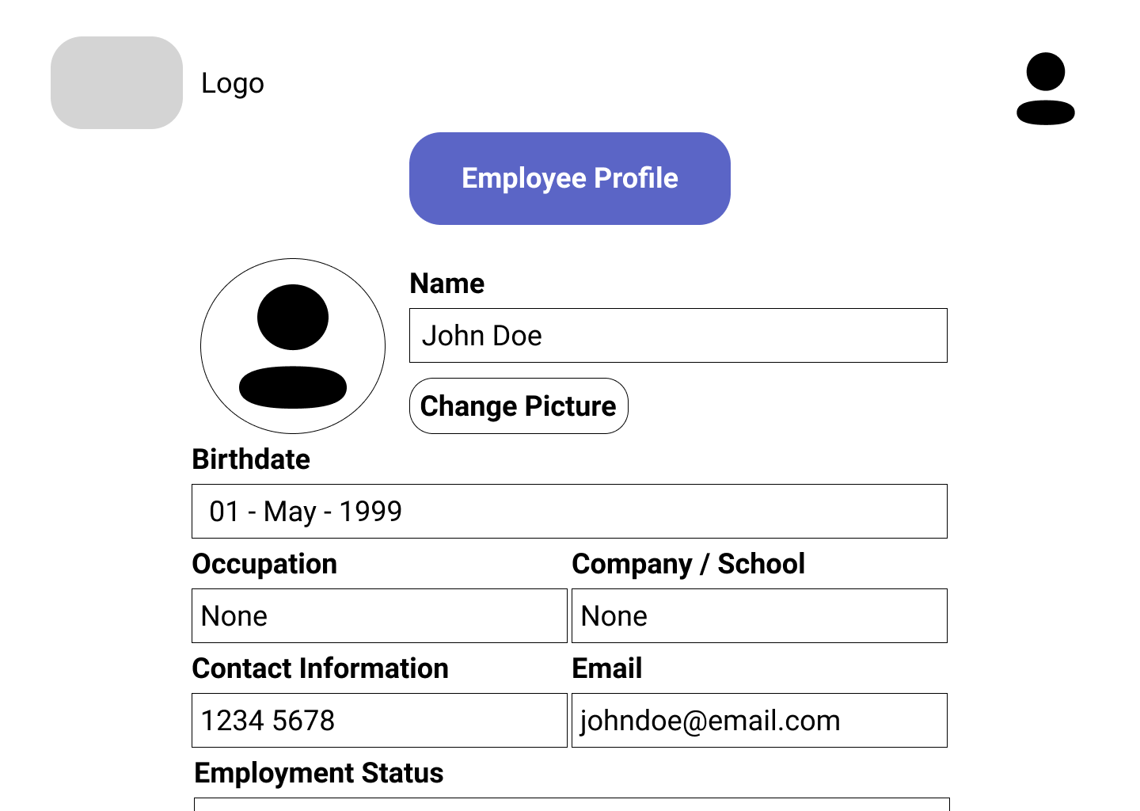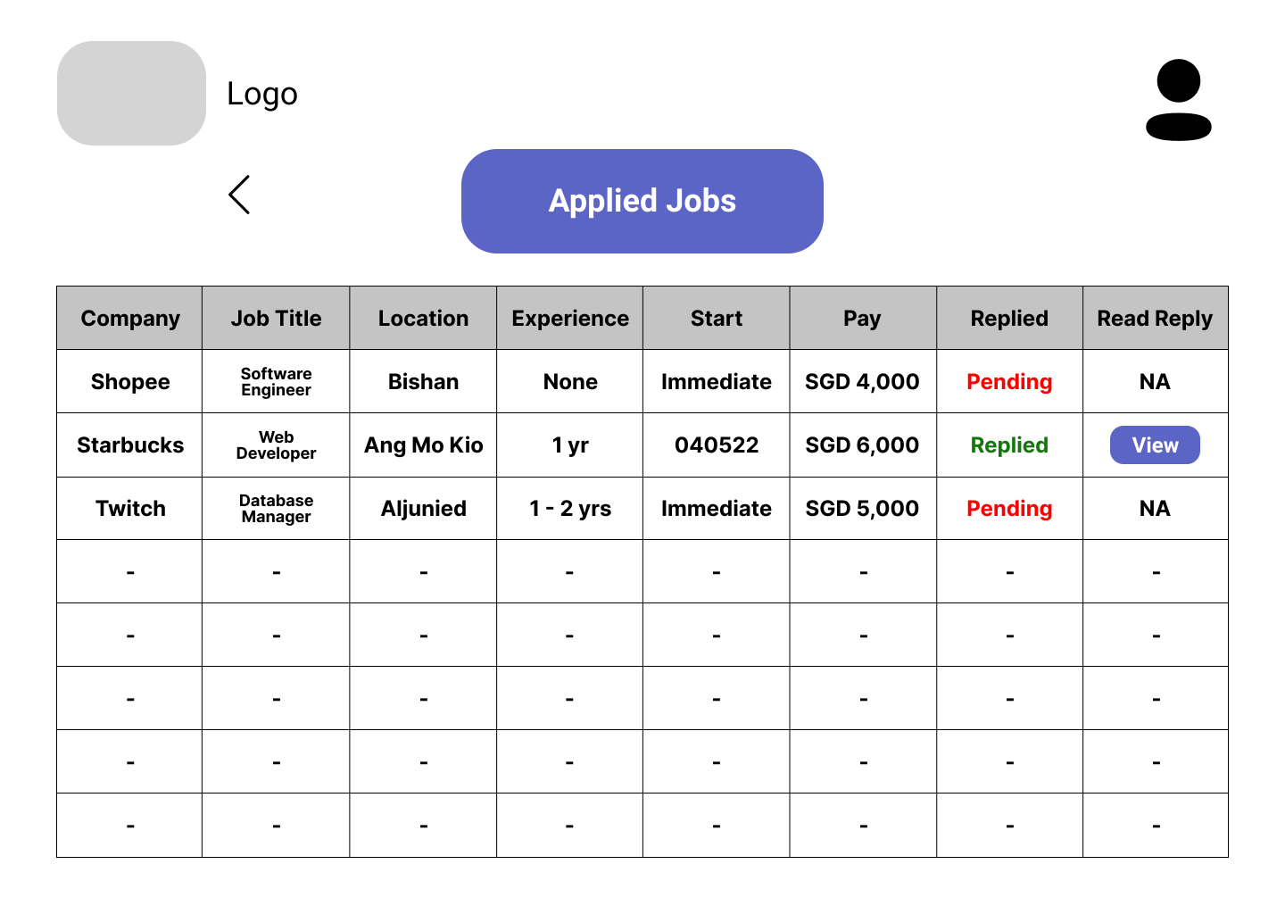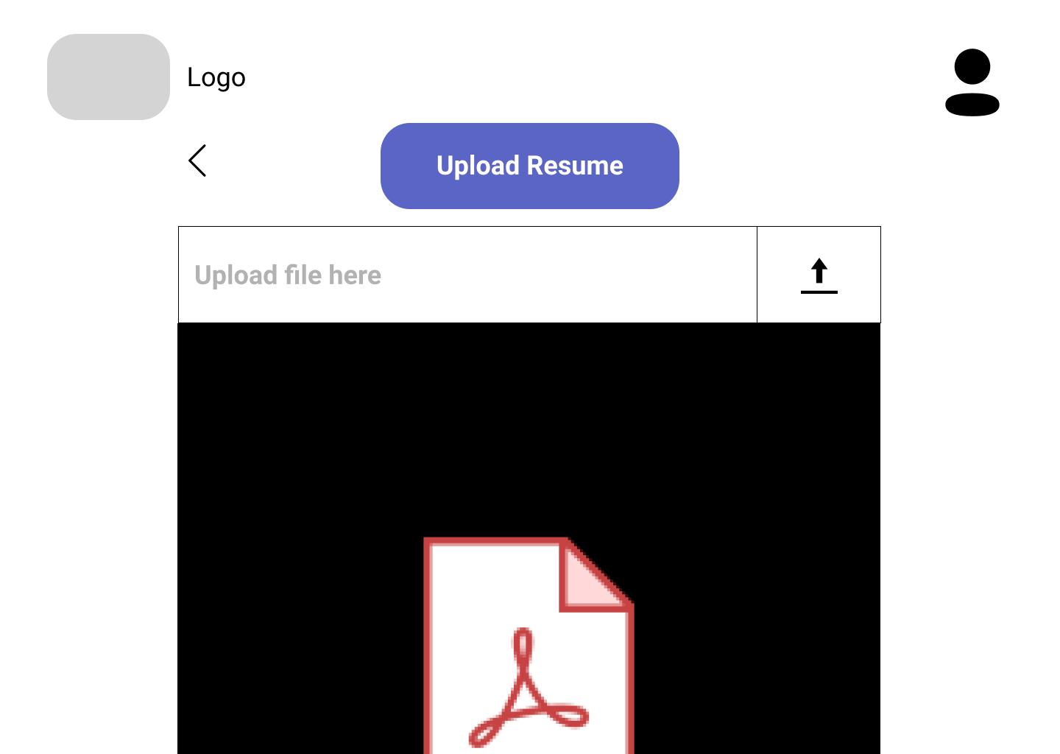

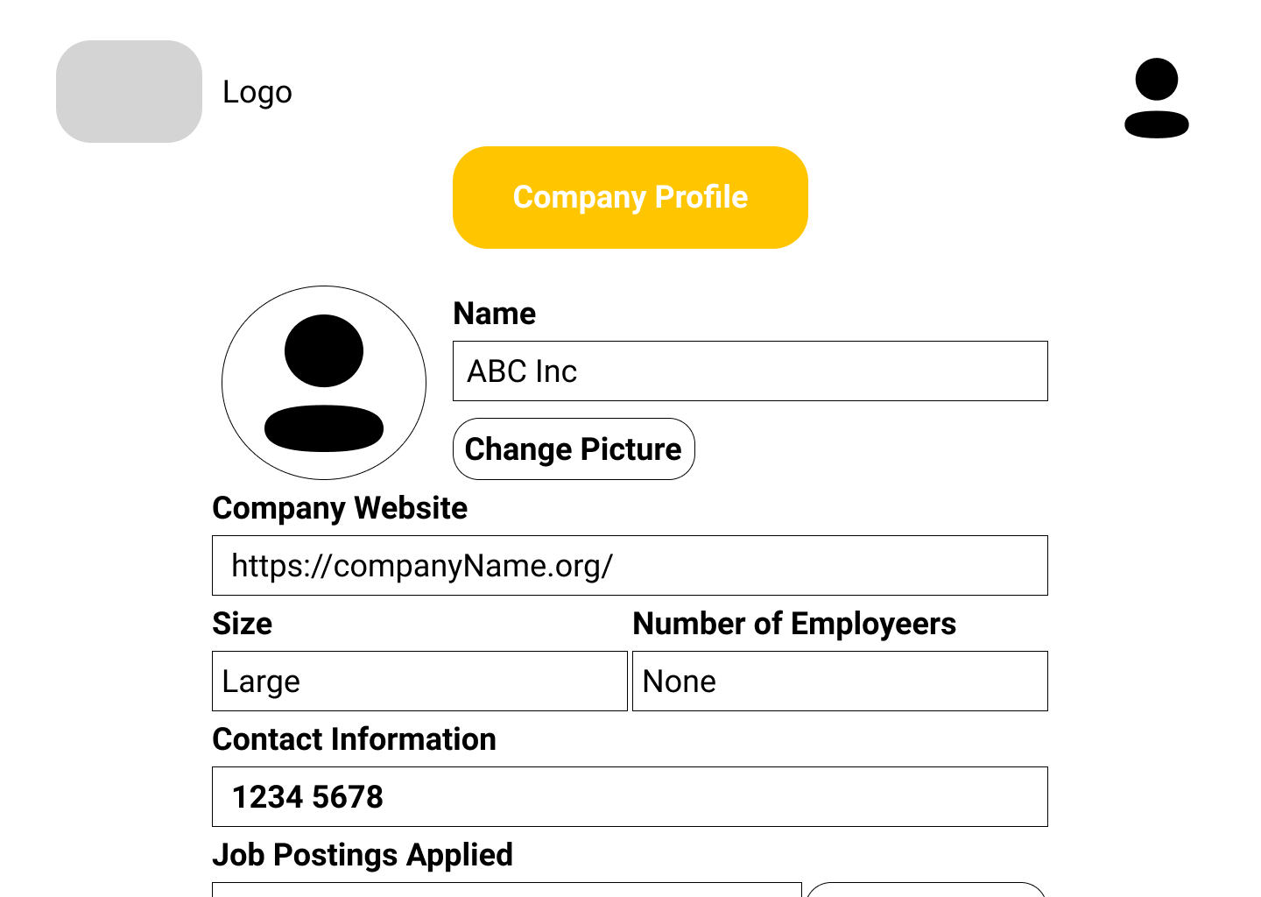

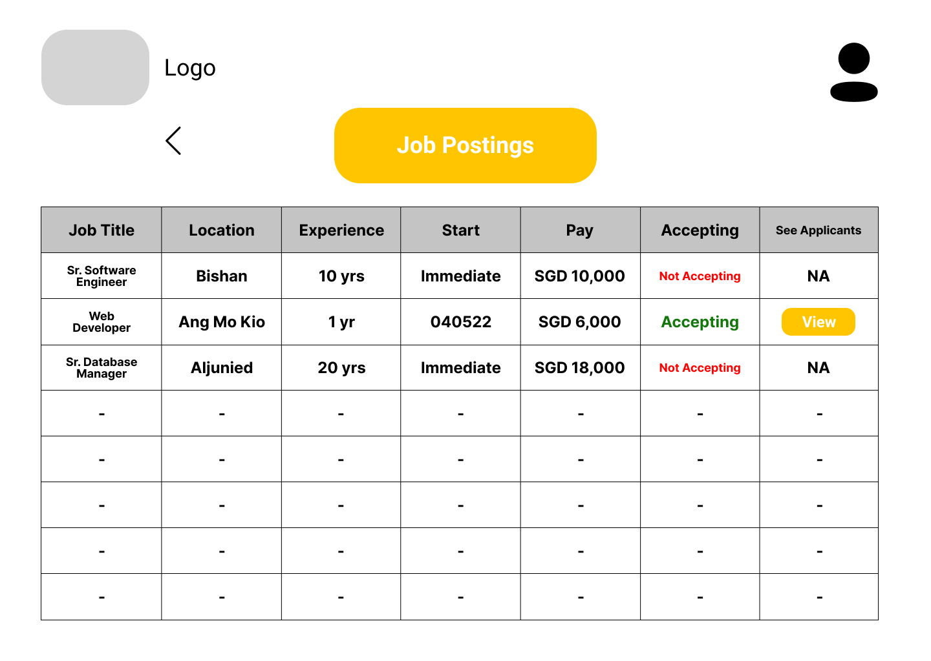

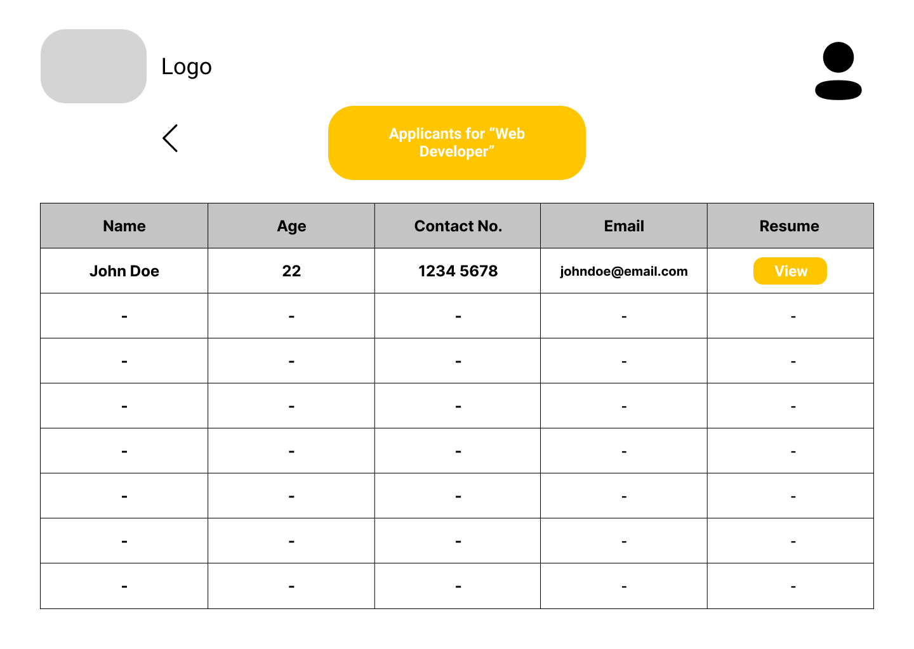

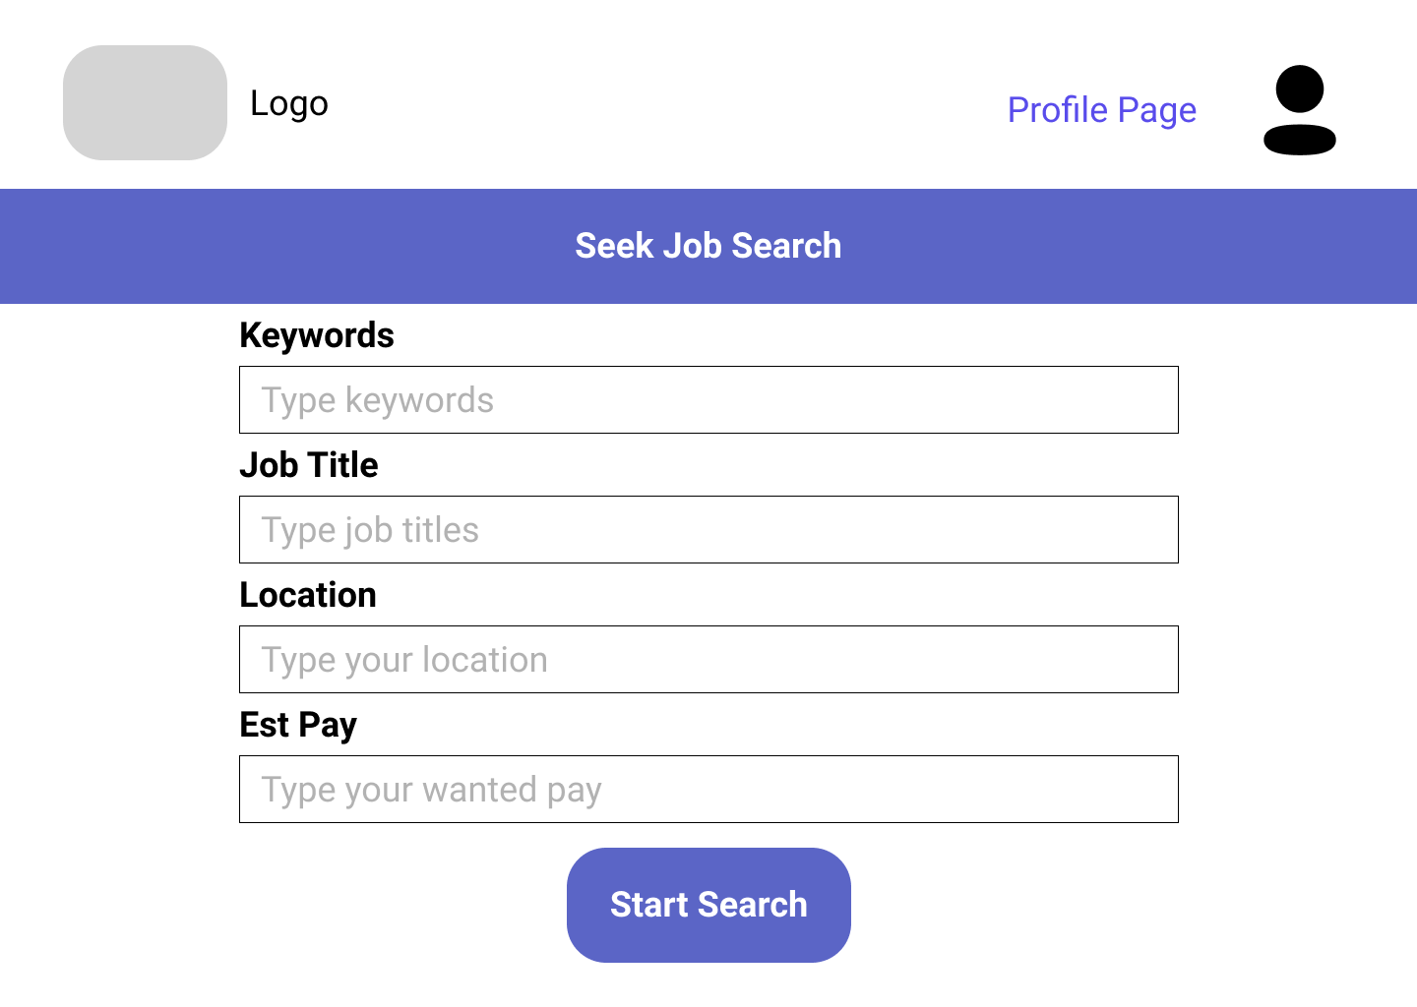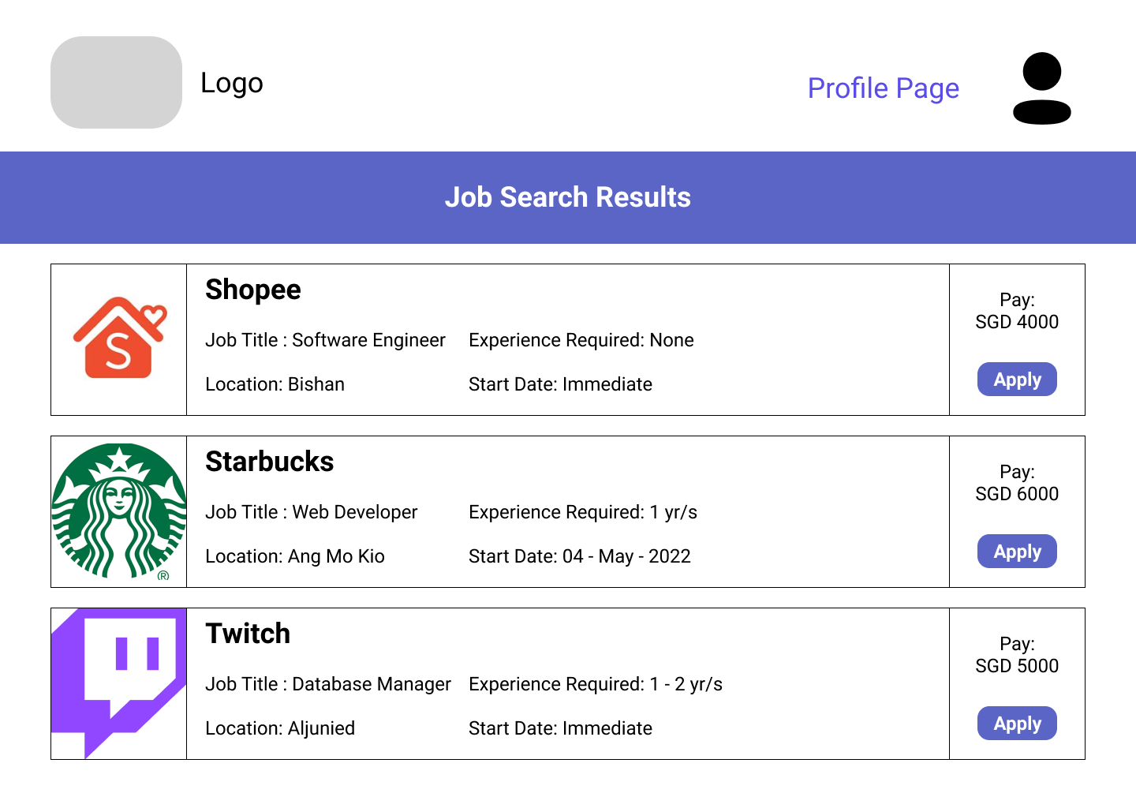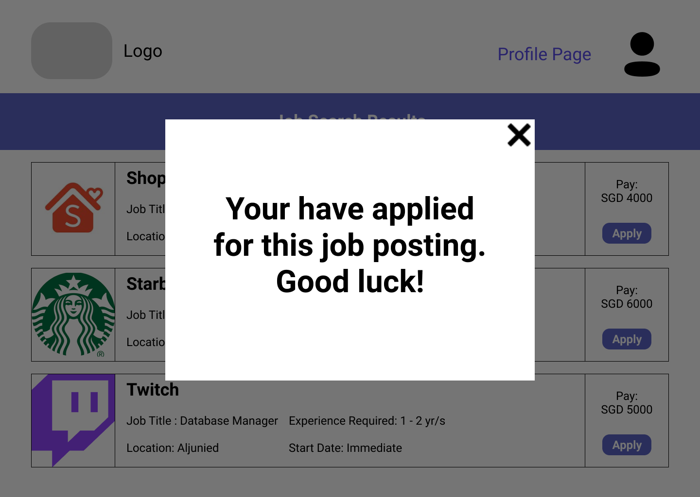

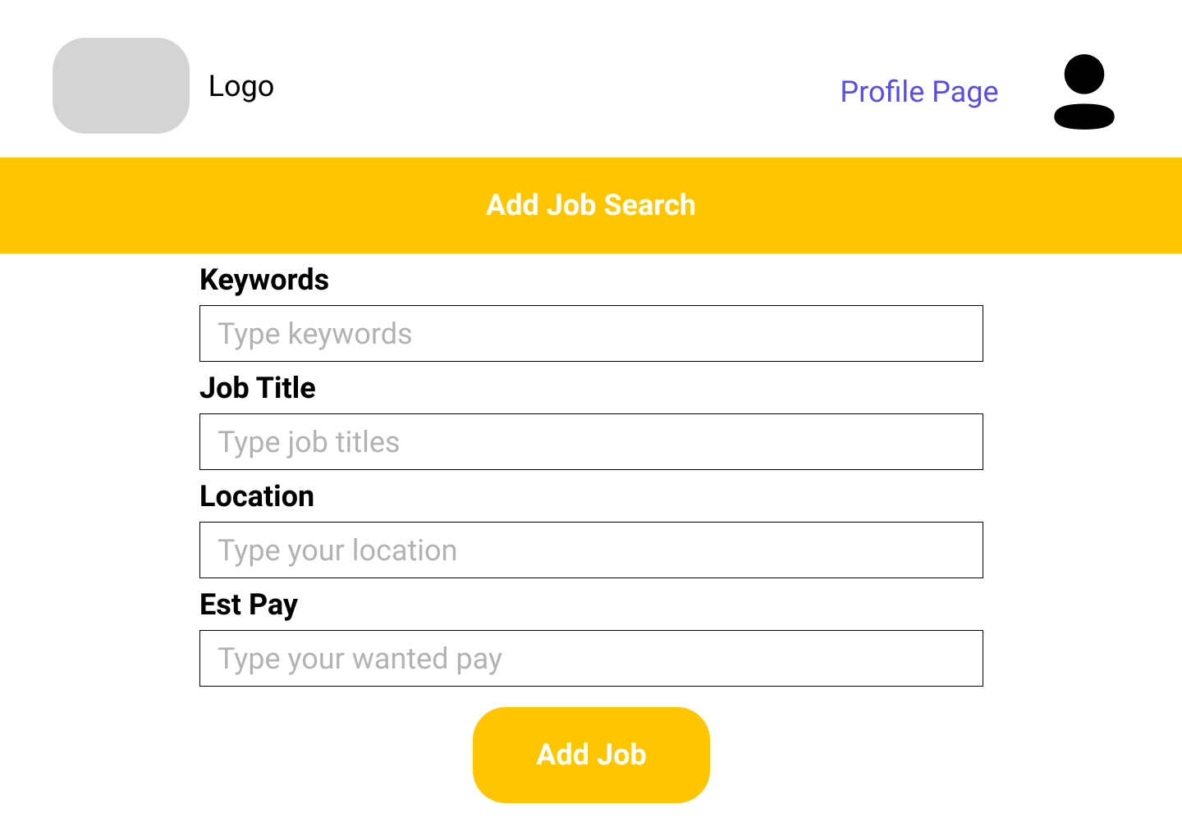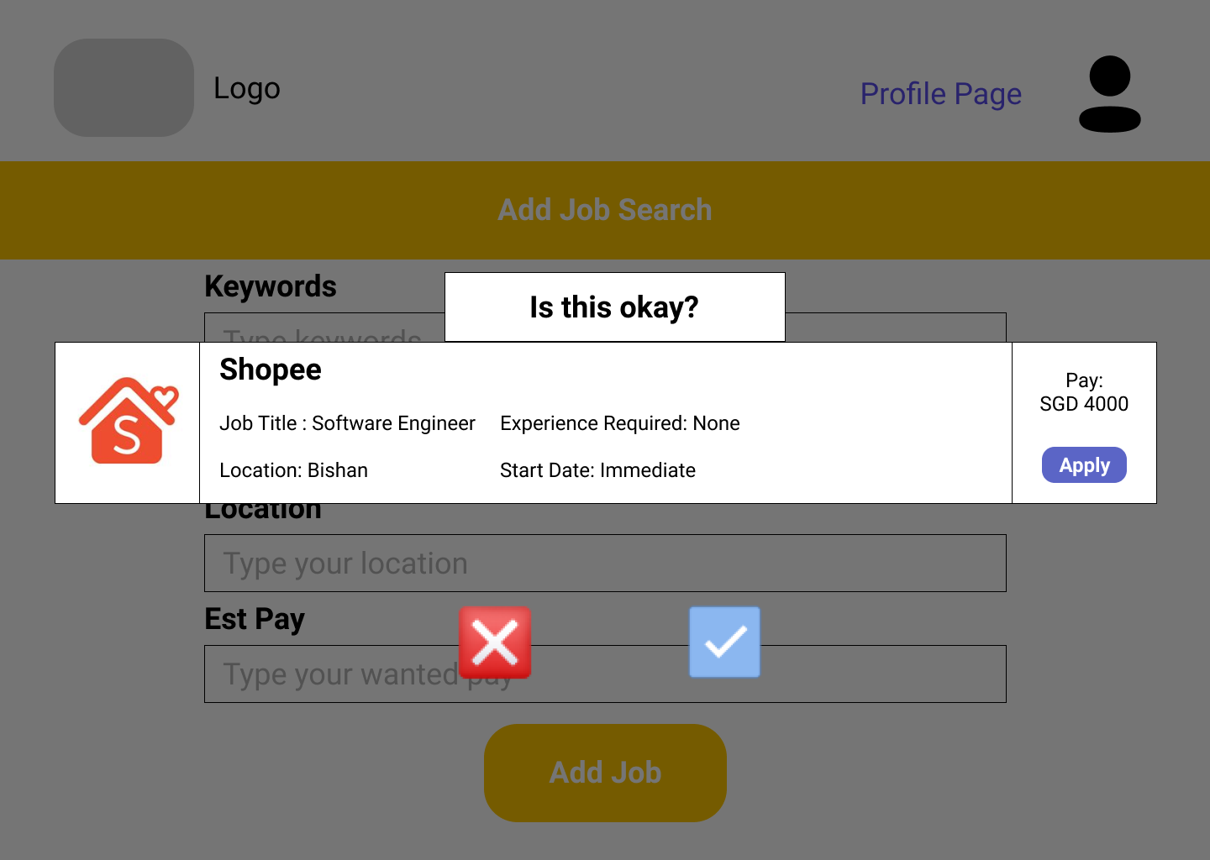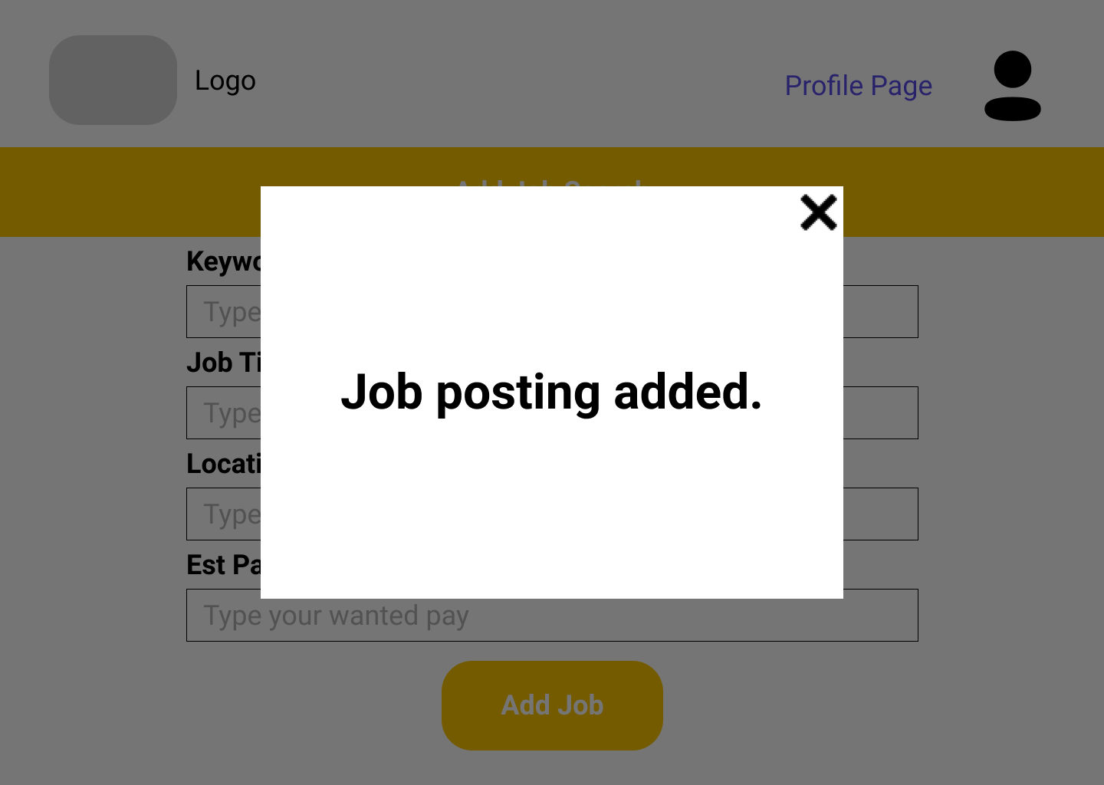

**References**

1. *COVID-19 impact: Singapore's economy contracts 41.2% on quarterly basis in April-June*. The Economic Times. (2021). Retrieved 24 April 2021, from <https://economictimes.indiatimes.com/news/international/business/covid-19-impact-singapores-economy-contracts-41-2-on-quarterly-basis-in-april-june/articleshow/76960695.cms>.
2. *Commentary: More bold measures needed to protect against the job losses heading Singapore's way*. CNA. (2021). Retrieved 25 April 2021, from <https://www.channelnewsasia.com/news/commentary/singapore-economy-jobs-support-unemployment-foreigners-budget-12947446>.
3. *Looking to 2021: Prospects for the Singapore economy and jobs market*. Looking to 2021: Prospects for the Singapore economy and jobs market. (2021). Retrieved 25 April 2021, from <https://news.nus.edu.sg/looking-to-2021-prospects-for-the-singapore-economy-and-jobs-market/>.
4. *Singapore's unemployment rates continue to decline in January: MOM*. (2021). Retrieved 24 April 2021, from <https://www.businesstimes.com.sg/government-economy/singapores-unemployment-rates-continue-to-decline-in-january-mom>.
5. *Singapore Unemployment Rate | 1986-2020 Data | 2021-2023 Forecast | Calendar*. Tradingeconomics.com. (2021). Retrieved 25 April 2021, from <https://tradingeconomics.com/singapore/unemployment-rate>.